Mysql Comprehensive Assessment

Topic : Library Management System  
You are going to build a project based on Library Management System. It keeps track of all information about books in the library, their cost, status and total number of books available in the library

Create a database named library and following TABLES in the database:

create DATABASE library ;

USE library;

1. Branch   
2. Employee   
3. Books  
4. Customer  
5. IssueStatus  
6. ReturnStatus   
  
Attributes for the tables:

1. Branch  
  
• Branch_no Set as PRIMARY KEY    
• Manager_Id    
• Branch_address    
• Contact_no

CREATE TABLE Branch(

Branch_no INT NOT NULL auto_increment,

Manager_Id INT NOT NULL,

Branch_address VARCHAR(100) NOT NULL,

Contact_no VARCHAR(20) NOT NULL,

primary key(Branch_no)

);

2. Employee    
  
• Emp_Id – Set as PRIMARY KEY    
• Emp_name    
• Position    
• Salary  
• Branch_no

* Set as FOREIGN KEY and it refer Branch_no in Branch table

CREATE TABLE Employee(

Emp_Id INT NOT NULL auto_increment,

Emp_name VARCHAR(50) NOT NULL,

Position VARCHAR(50),

Salary DECIMAL(10,2),

Branch_no INT,

primary key(Emp_Id),

foreign key(Branch_no) references Branch(Branch_no)

);

3. Books    
  
• ISBN Set as PRIMARY KEY    
• Book_title    
• Category    
• Rental_Price    
• Status [Give yes if book available and no if book not available]    
• Author    
• Publisher

CREATE TABLE Books(

ISBN INT NOT NULL auto_increment,

Book_title VARCHAR(50) NOT NULL,

Category VARCHAR(50) NOT NULL,

Rental_Price DECIMAL(10,2) NOT NULL,

Status VARCHAR(10) NOT NULL COMMENT 'Give yes if book available and no if book not available',

Author varchar(50) NOT NULL,

Publisher varchar(50) NOT NULL,

primary key(ISBN)

);

4. Customer    
  
• Customer_Id Set as PRIMARY KEY    
• Customer_name    
• Customer_address    
• Reg_date

create table Customer(

Customer_Id int not null auto_increment,

Customer_name varchar(50) not null,

Customer_address varchar(100) not null,

Reg_date date not null,

primary key(Customer_Id)

);

5. IssueStatus    
  
• Issue_Id Set as PRIMARY KEY    
• Issued_cust – Set as FOREIGN KEY and it refer customer_id in CUSTOMER table  Issued_book_name   
• Issue_date   
• Isbn_book – Set as FOREIGN KEY and it should refer isbn in BOOKS table

create table IssueStatus(

Issue_Id int not null auto_increment,

Issued_cust int not null,

Issue_date date not null,

Isbn_book int not null,

primary key(Issue_Id),

foreign key(Issued_cust) references Customer(Customer_Id),

foreign key(Isbn_book) references Books(ISBN)

);

6. ReturnStatus    
  
• Return_Id

* Set as PRIMARY KEY    
  • Return_cust    
  • Return_book_name    
  • Return_date    
  • Isbn_book2
* Set as FOREIGN KEY and it should refer isbn in BOOKS table

create table ReturnStatus(

Return_Id int not null auto_increment,

Return_cust int,

Return_book_name varchar(50),

Return_date date not null,

Isbn_book2 int not null,

primary key(Return_Id),

foreign key(Isbn_book2) references Books(ISBN),

foreign key(Return_cust) references Customer(Customer_Id)

);

**Insert values into the table**

INSERT INTO Branch (Branch_no, Manager_Id, Branch_address, Contact_no)

VALUES

(1, 1001, '123 Main St, Cityville', '555-1234'),

(2, 1002, '456 Elm St, Townsville', '555-5678'),

(3, 1003, '789 Oak St, Villageville', '555-8765');

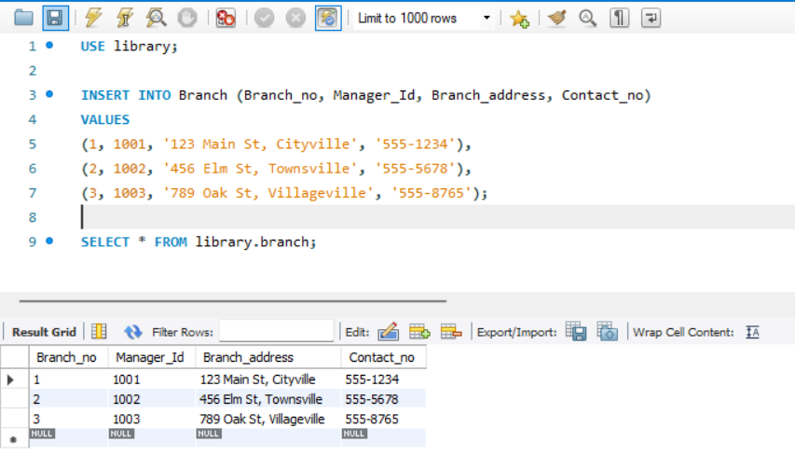

INSERT INTO Employee (Emp_Id, Emp_name, Position, Salary, Branch_no)

VALUES

(1, 'Alice Smith', 'Manager', 60000, 1),

(2, 'Bob Johnson', 'Assistant', 40000, 1),

(3, 'Carol White', 'Manager', 65000, 2),

(4, 'David Brown', 'Clerk', 35000, 2),

(5, 'Eve Davis', 'Assistant', 42000, 3),

(6, 'Frank Miller', 'Clerk', 37000, 3),

(7, 'John Lock', 'Assistant', 34000, 3),

(8, 'James Dennis', 'Assistant', 40000, 3),

(9, 'Jack Shepherd', 'Assistant', 44000, 3),

(10, 'Jonas Jacob', 'Assistant', 48000, 3);

SELECT * FROM employee;

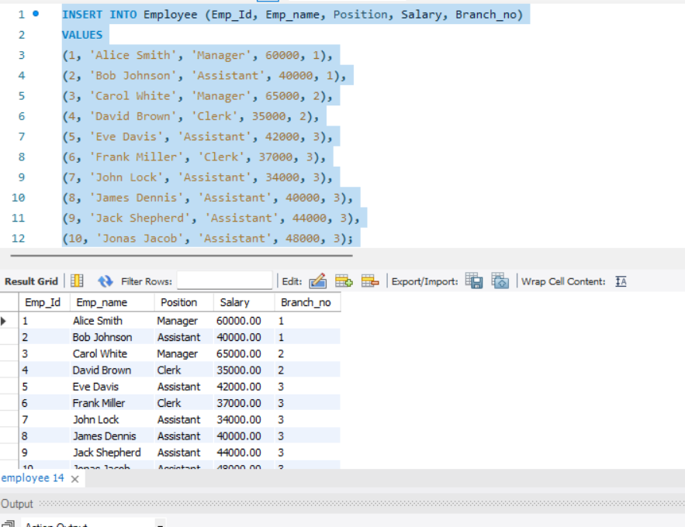

INSERT INTO Books (Book_title, Category, Rental_Price, Status, Author, Publisher)

VALUES

('The Great Gatsby', 'Fiction', 30.00, 'yes', 'F. Scott Fitzgerald', 'Scribner'),

('To Kill a Mockingbird', 'Fiction', 25.00, 'no', 'Harper Lee', 'J.B. Lippincott & Co.'),

('The Road', 'Post-Apocalyptic', 22.00, 'yes', 'Cormac McCarthy', 'Vintage'),

('The Girl with the Dragon Tattoo', 'Mystery', 28.00, 'yes', 'Stieg Larsson', 'Knopf'),

('Sapiens', 'History', 47.00, 'yes', 'Yuval Noah Harari', 'Amazon');

SELECT * FROM library.books;

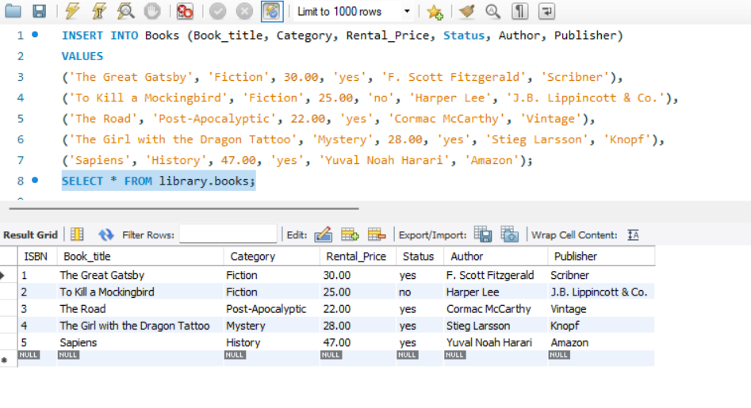

INSERT INTO Customer (Customer_Id, Customer_name, Customer_address, Reg_date)

VALUES (1, 'John Doe', '456 Elm St, Cityville', '2021-05-15'),

(2, 'Jane Roe', '789 Pine St, Townsville', '2021-07-22'),

(3, 'Alice Johnson', '321 Maple St, Villageville', '2022-01-10'),

(4, 'Rayan Johnson', '321 Maple St, Villageville', '2021-01-10');

SELECT * FROM library.customer; 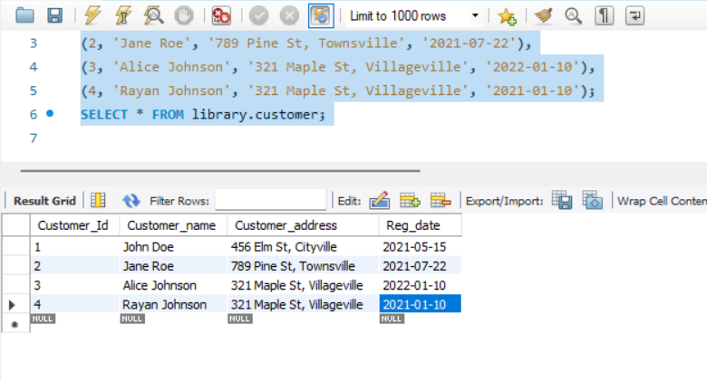

INSERT INTO IssueStatus (Issue_Id, Issued_cust, Issue_date, Isbn_book)

VALUES

(1, 1,'2023-06-01', 1),

(2, 2,'2023-06-05', 3);

SELECT * FROM library.issuestatus;

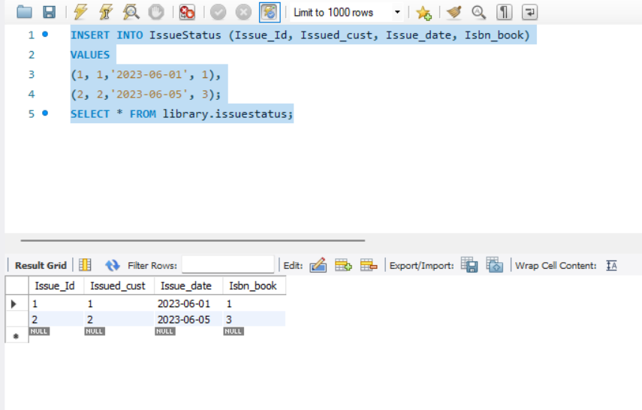

INSERT INTO ReturnStatus (Return_Id, Return_cust, Return_book_name, Return_date, Isbn_book2)

VALUES

(1, 1, 'The Great Gatsby', '2023-06-15', 1),

(2, 2, 'The Road', '2023-06-20', 3);

SELECT * FROM library.returnstatus;

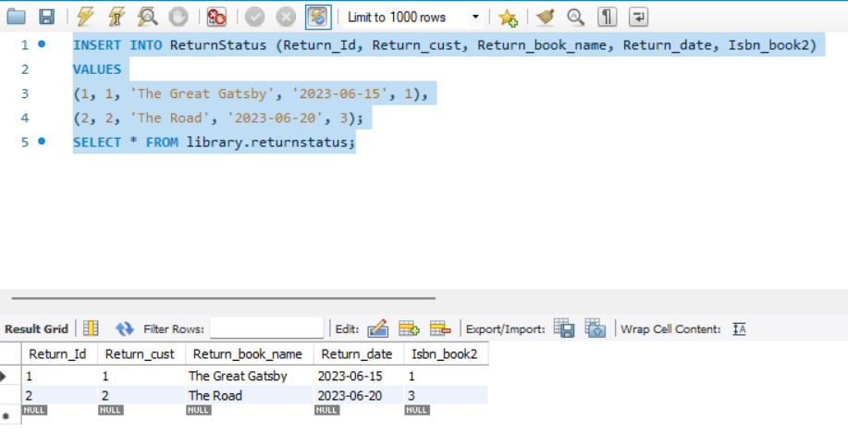

1. **Retrieve the book title, category, and rental price of all available books**.

SELECT Book_title,Category,Rental_Price FROM library.books;

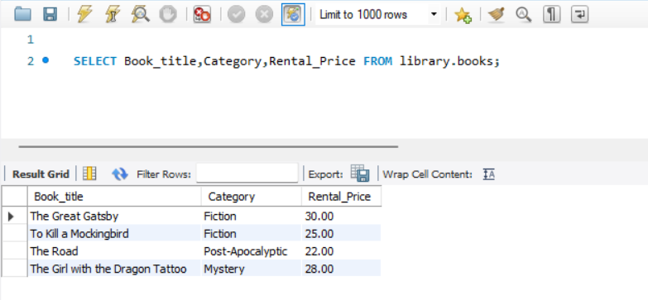

1. **List the employee names and their respective salaries in descending order of salary.**

SELECT Emp_name,Salary FROM library.employee order by Salary DESC;

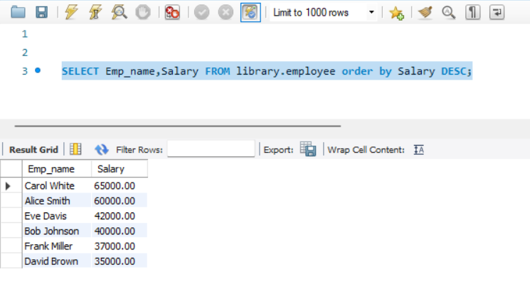

1. **Retrieve the book titles and the corresponding customers who have issued those books.**

SELECT b.Book_title,c.Customer_name,i.Issue_date FROM issuestatus i

JOIN customer c ON c.Customer_Id = i.Issued_cust

JOIN books b ON b.ISBN = i.Isbn_book;

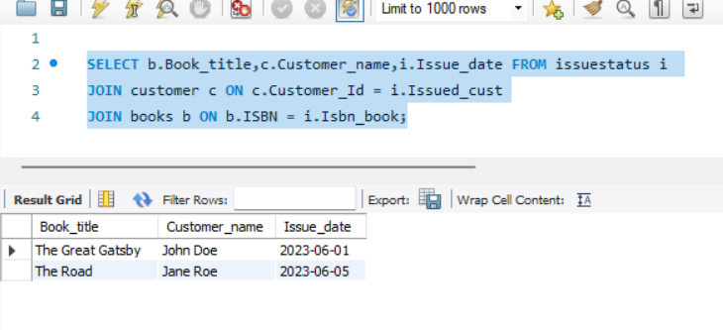

**4. Display the total count of books in each category.**

SELECT Category,COUNT(*) as number_of_books from books group by Category;

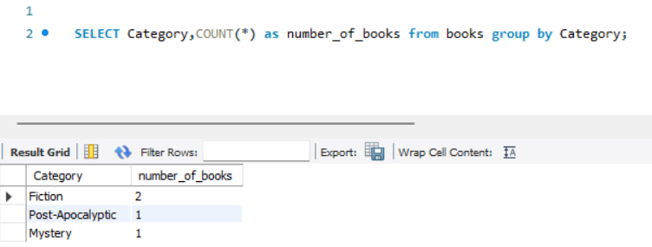

**5.Retrieve the employee names and their positions for the employees whose salaries are above Rs.50,000.**

SELECT Emp_name, Position, Salary from employee Where Salary > 50000;

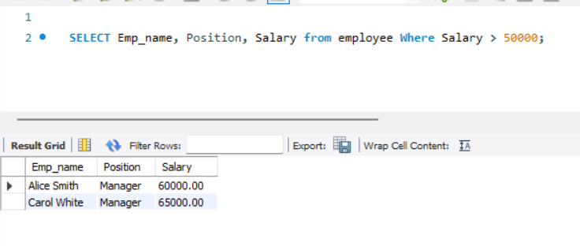

**6. List the customer names who registered before 2022-01-01 and have not issued any books yet.**

select c.Customer_name,c.Reg_date from customer c

LEFT JOIN issuestatus i ON c.Customer_Id = i.Issued_cust

WHERE c.reg_date < '2022-01-01' AND i.Issued_cust IS null;

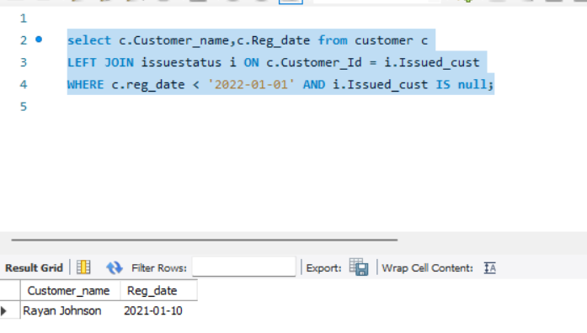

**7. Display the branch numbers and the total count of employees in each branch.**

SELECT Branch_no,COUNT(*) AS count_of_employees from employee

group by Branch_no ;

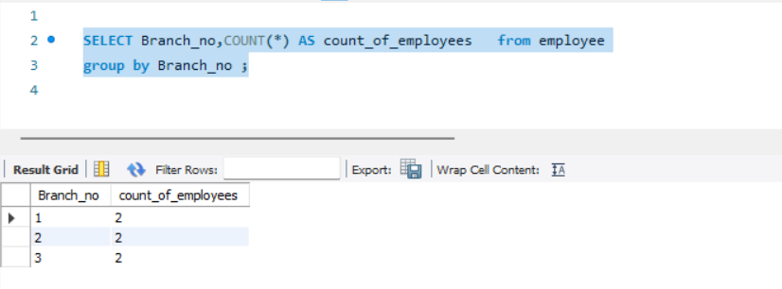

**8. Display the names of customers who have issued books in the month of June 2023**.

SELECT i.Issue_date,c.Customer_name FROM issuestatus i

JOIN customer c ON i.Issued_cust = c.Customer_Id

WHERE YEAR(i.Issue_date) = 2023 AND MONTH(i.Issue_date) = 6;

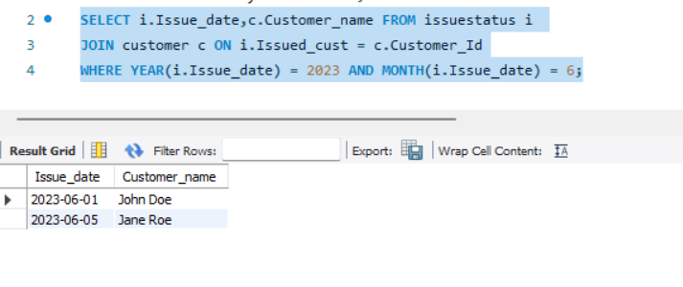

**9. Retrieve book_title from book table containing history**.

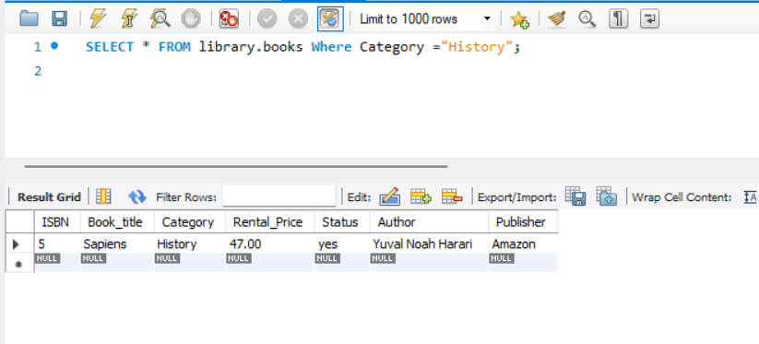

**10.Retrieve the branch numbers along with the count of employees for branches having more than 5 employees**

SELECT Branch_no,COUNT(*) AS employee_count FROM employee

GROUP BY Branch_no

HAVING COUNT(*) >=5 ;

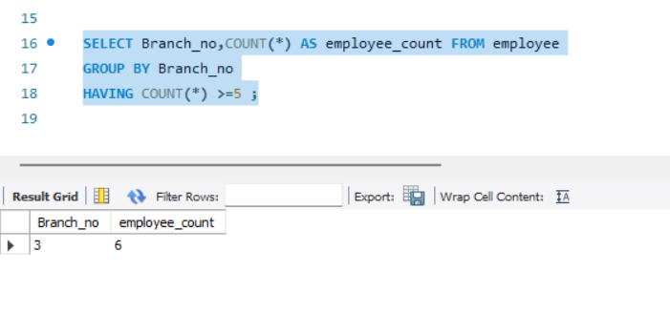

**11. Retrieve the names of employees who manage branches and their respective branch addresses.**

SELECT e.Emp_name,b.Branch_address FROM employee e

JOIN branch b ON e.Branch_no = b.Branch_no

WHERE e.Position like '%Manager%';

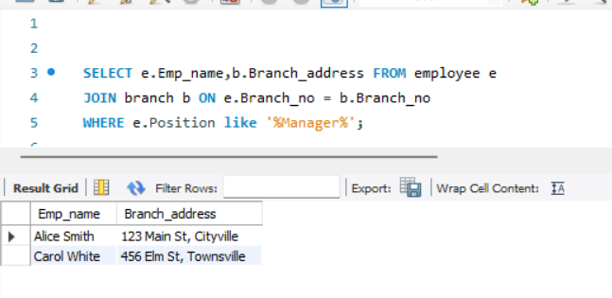

**12.  Display the names of customers who have issued books with a rental price higher than Rs. 25.**

SELECT c.Customer_name,b.Rental_Price

FROM customer c

JOIN issuestatus i ON i.Issued_cust = c.Customer_Id

JOIN books b ON b.ISBN = i.Isbn_book

WHERE b.Rental_Price > 25 ;

